**DB프로그래밍 쇼핑몰 중간평가**

**20173009 김찬우**

1) 초기화면 구성

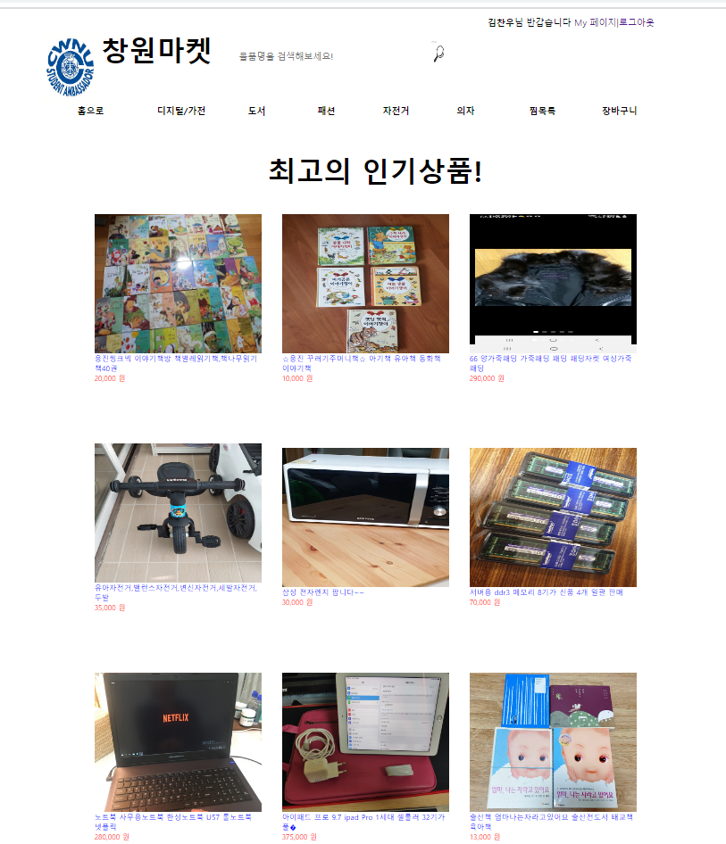

상단부



하단부

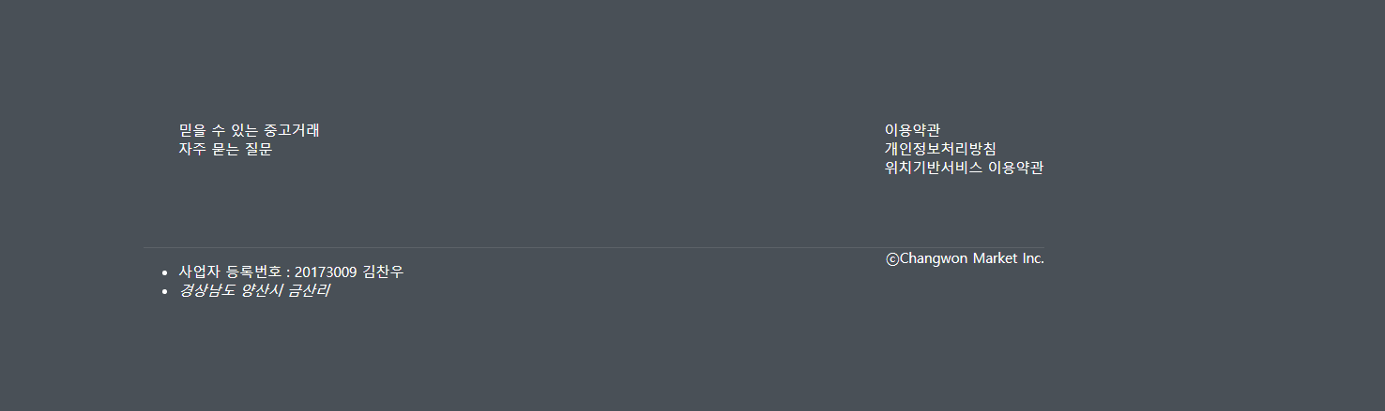

2) 상품설명 페이지

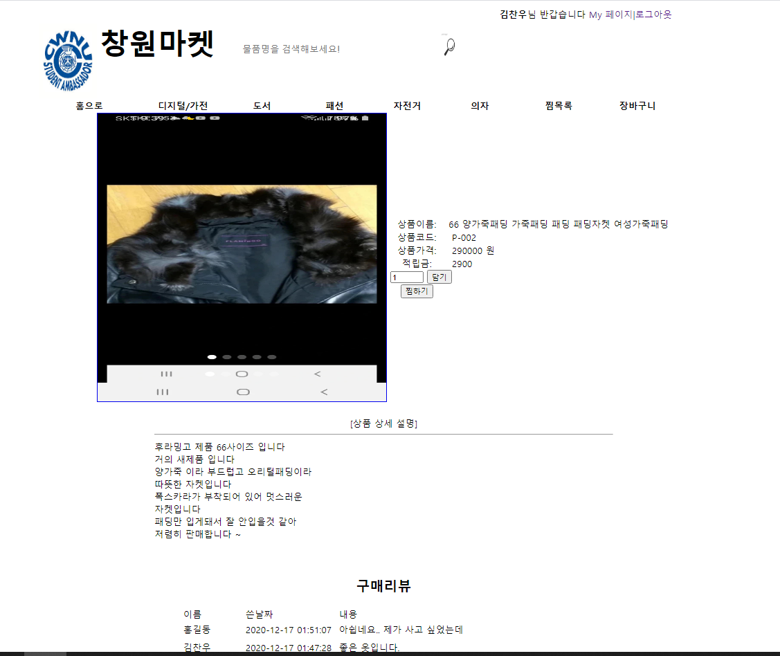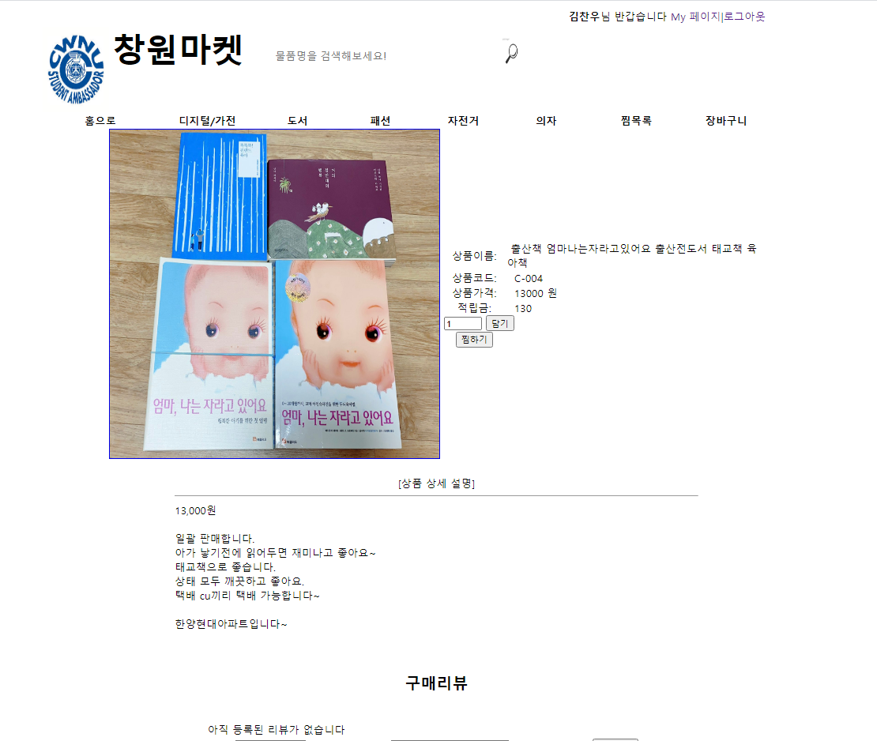

3) 구매후기

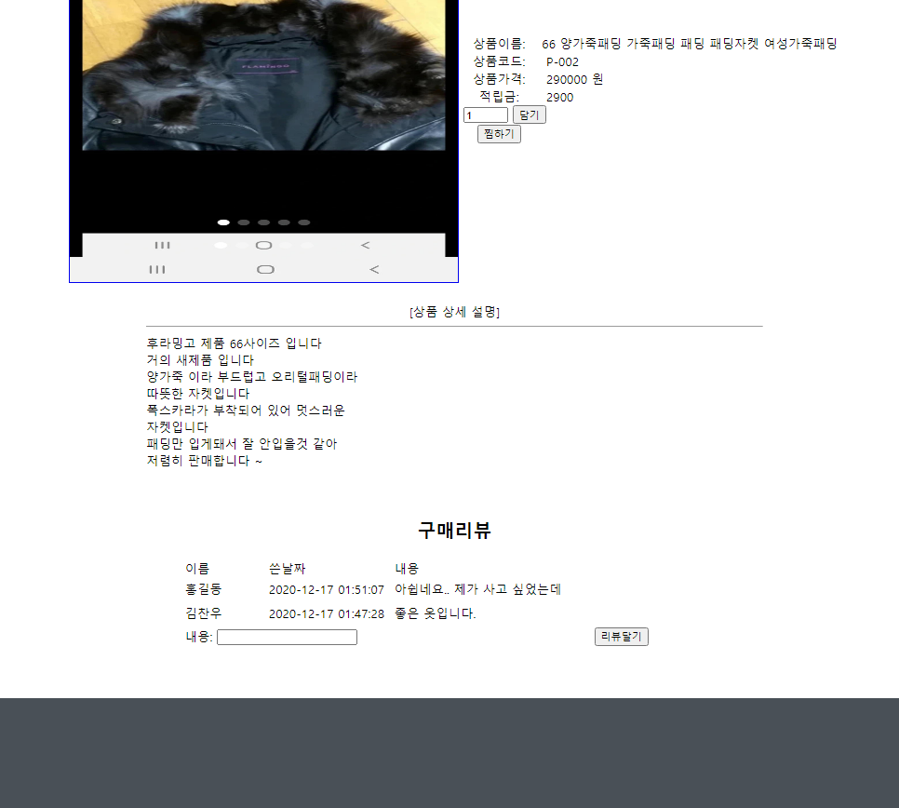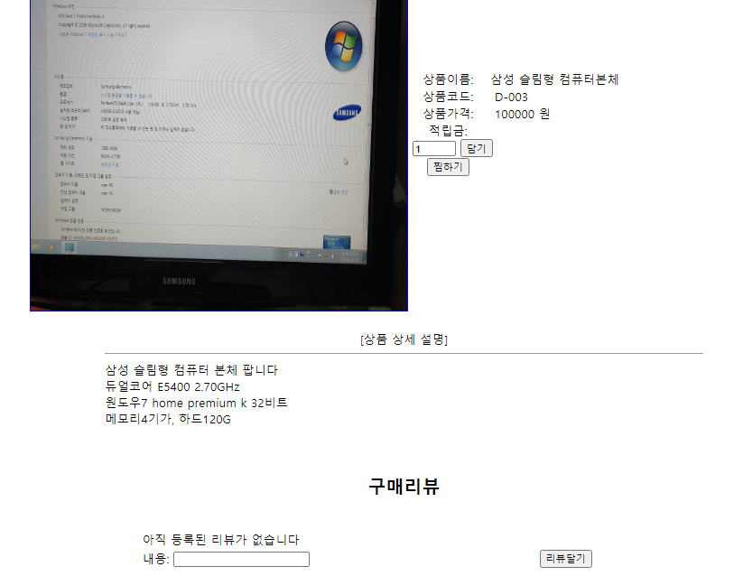

4) 쇼핑백

장바구니

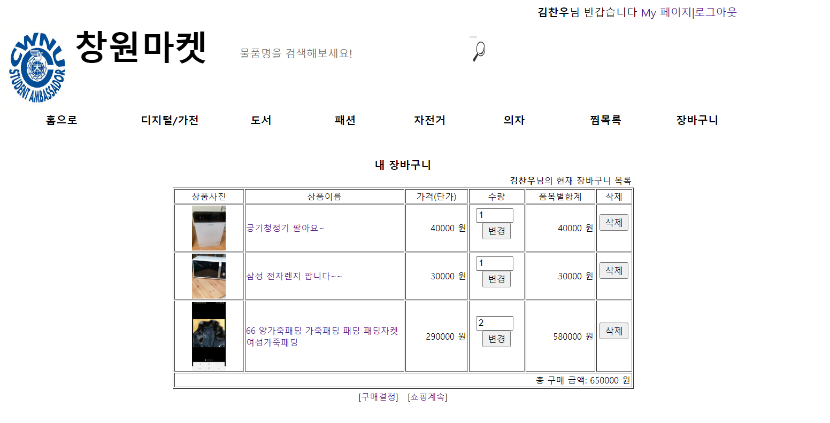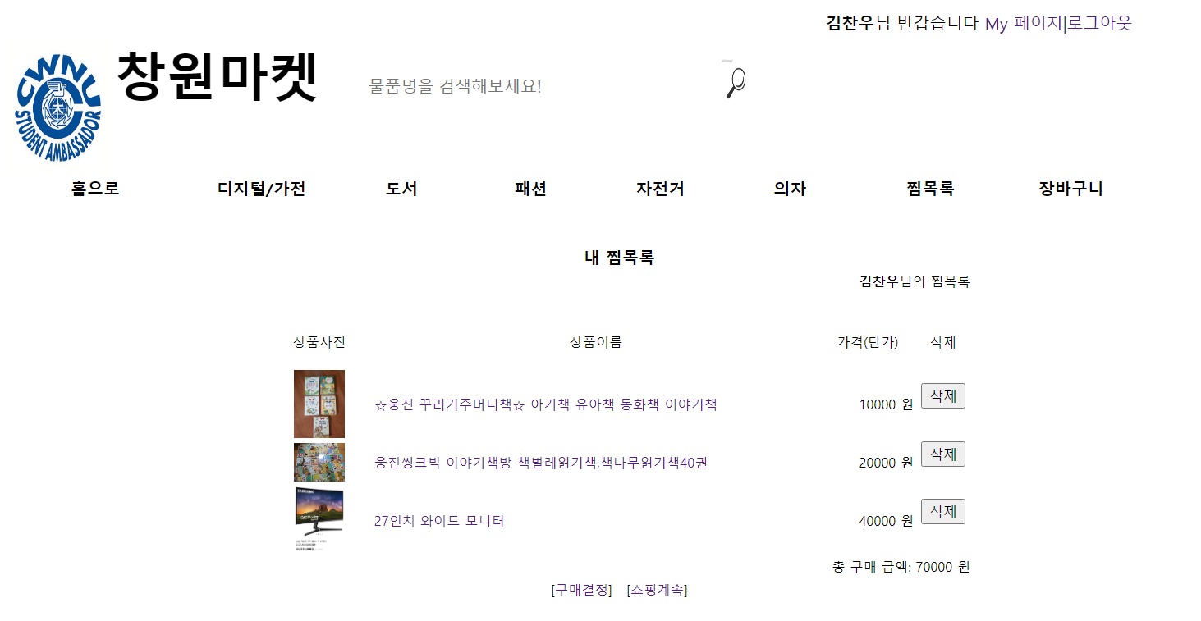

찜목록

5) 주문완료

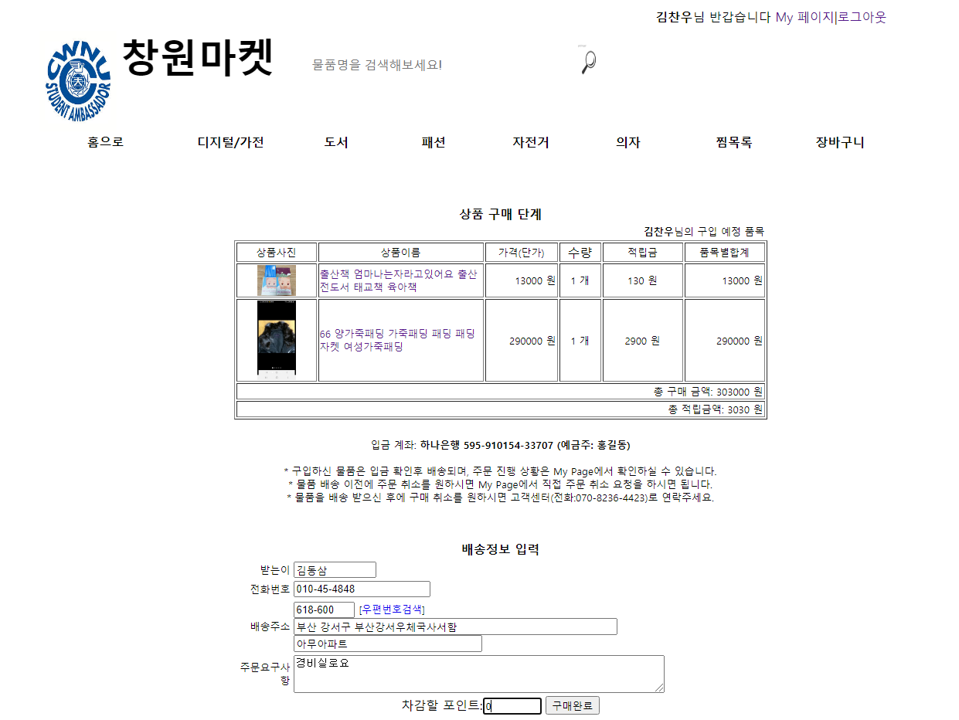

6) 포인트

현재 내 포인트

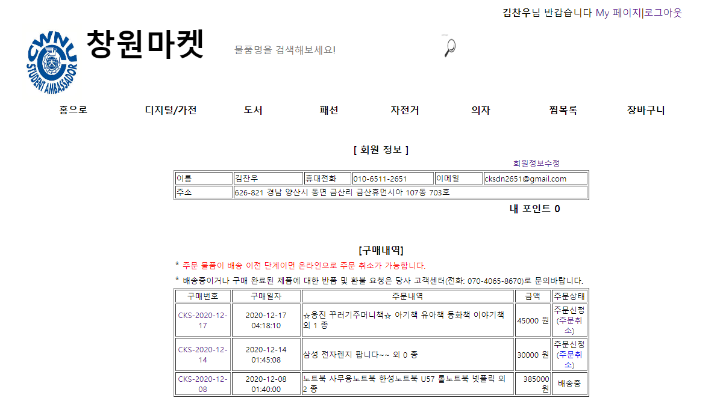

샀을 때 포인트 증감.

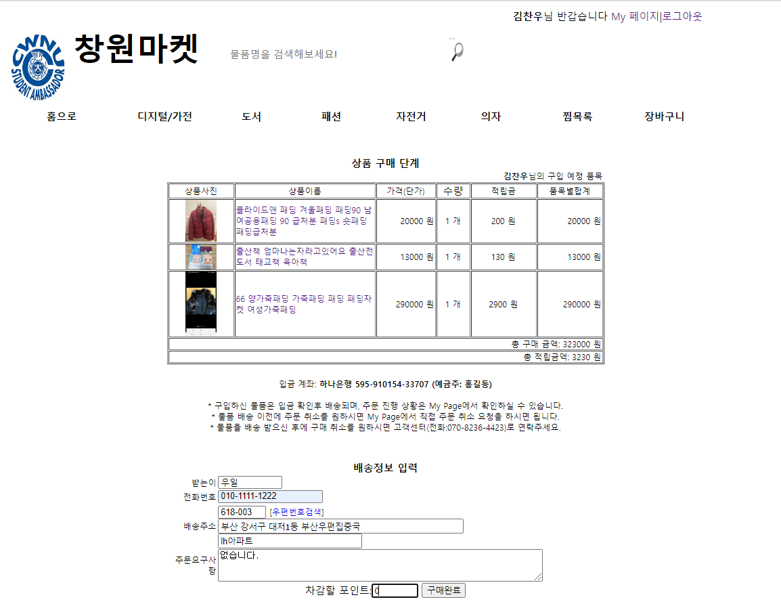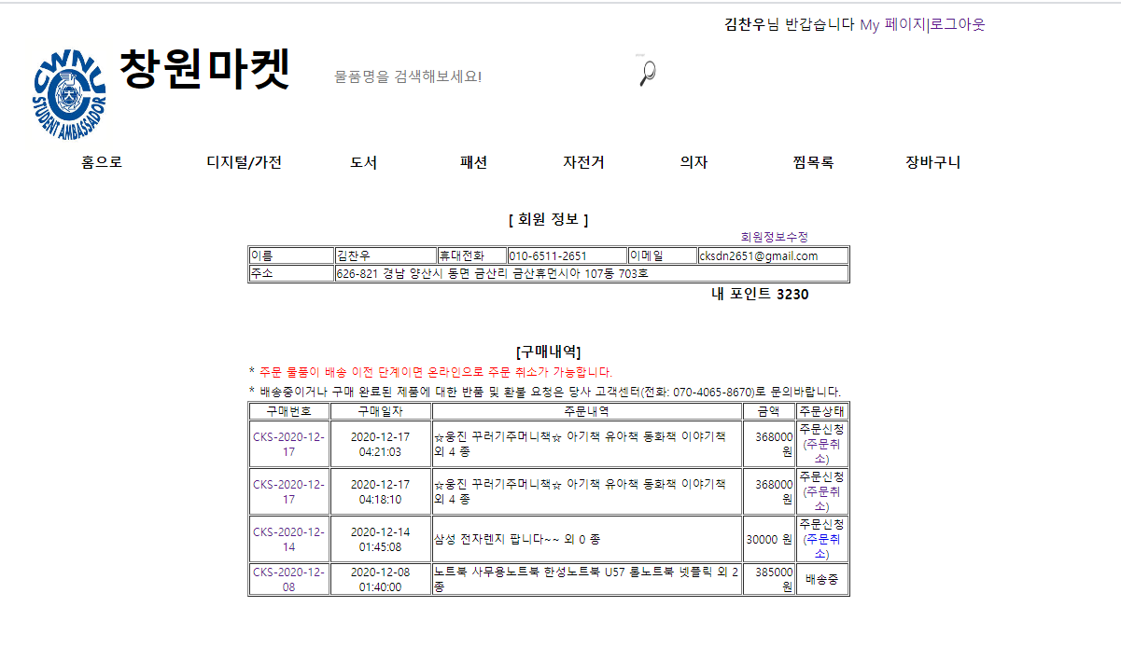

7) 관리자

관리자 페이지



공지사항

공지사항 게시판

8) Mypage

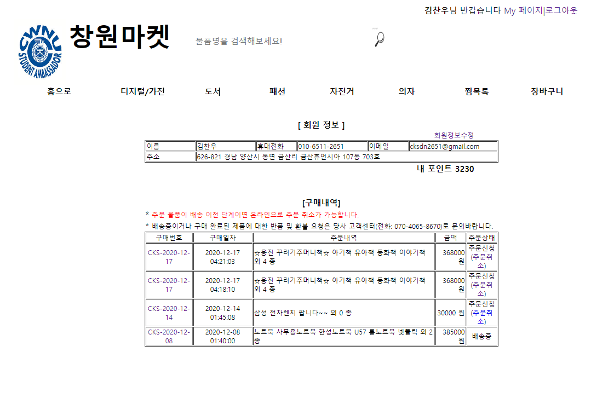

회원정보

9) 회원가입

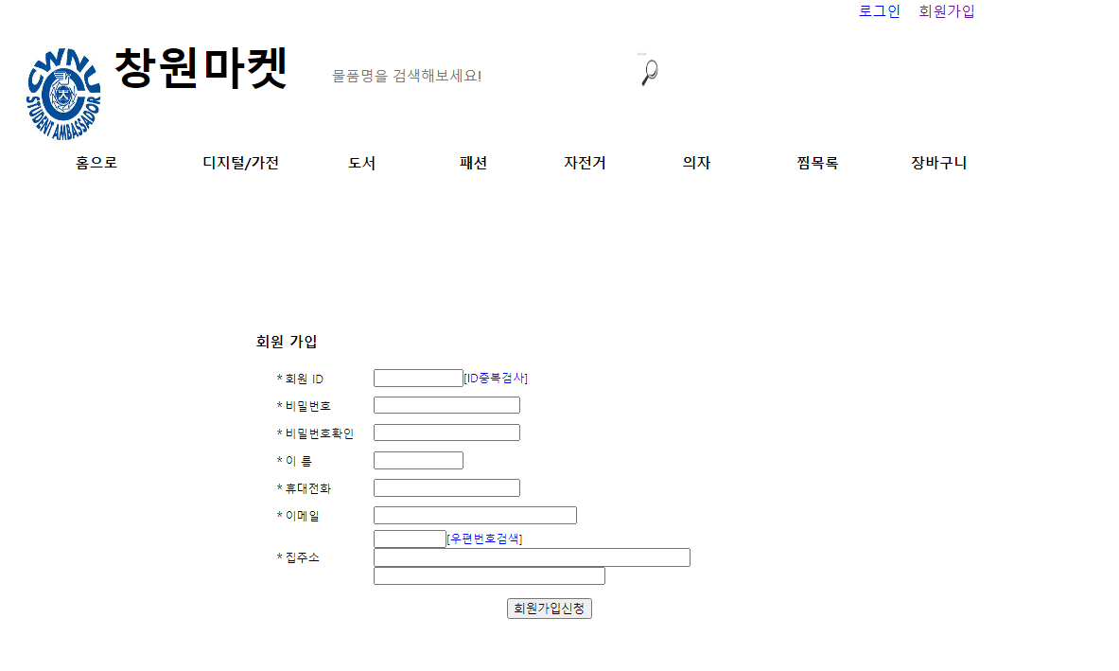

10) 상품검색

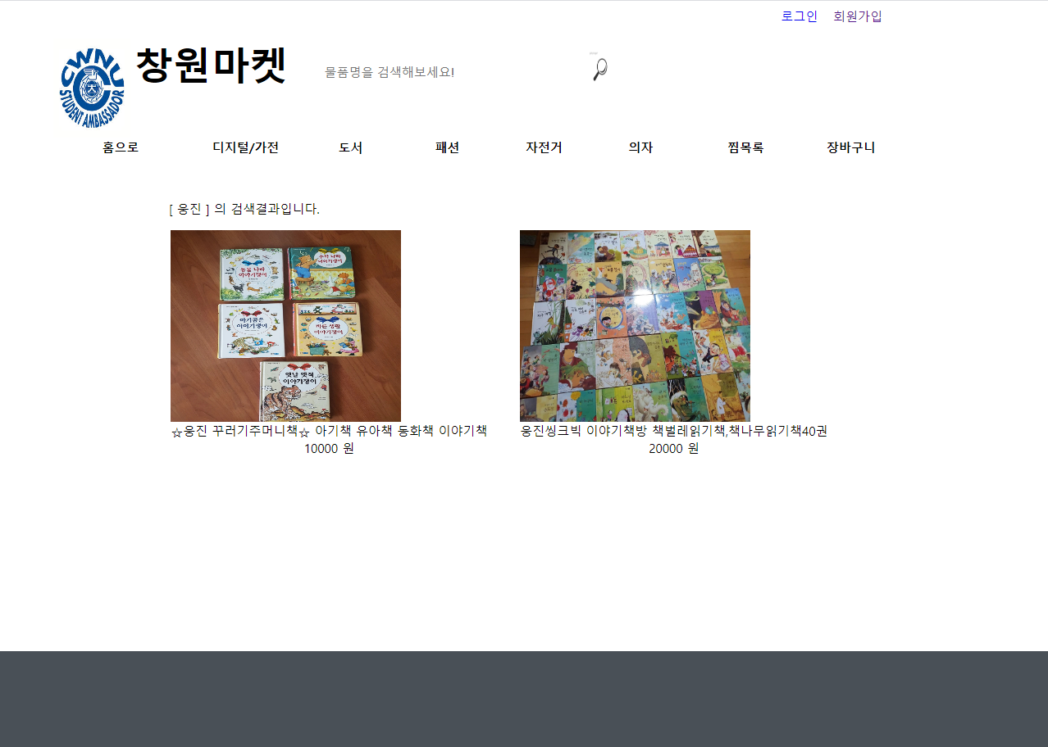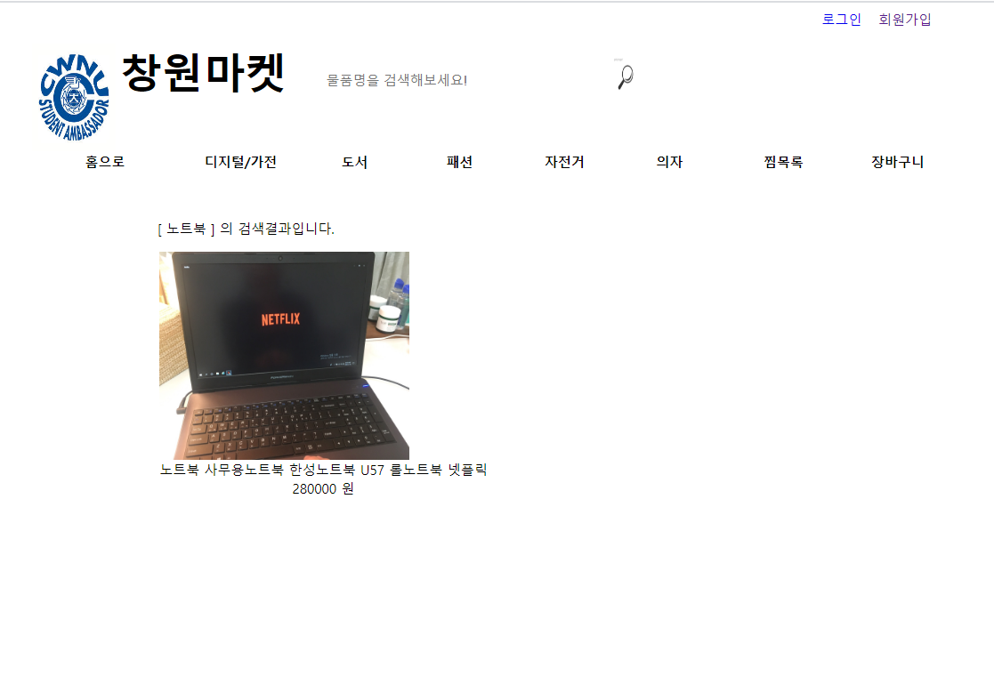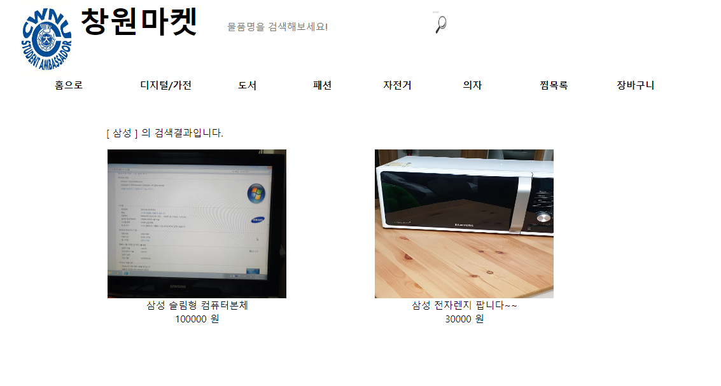

<top.html>

<html>

<head>

<title>창원마켓</title>

<style>

#side-navbar{

display: inline;

}

#imga{vertical-align: top}

h1 {display:inline; font-size: 50px; vertical-align: top; text-align:center}

a { text-decoration:none }

#inputt {

width: 340px;

height: 90px;

border: none;

font-size: 16px;

color: #212529;

background-color: transparent;

vertical-align: top;

}

#fixedd{

width: 30px;

height: 50px;

fill: #868e96;

padding: 1rem 0;

}

button {

background: none;

color: inherit;

border: none;

padding: 0;

font: inherit;

cursor: pointer;

outline: inherit;

}

#result{

position: relative;

text-align: left;

display: inline-block;

width: 300px;

margin-right: 34px;

margin-bottom: 40px;

}

footer {

background-color: #495057;

color: #fff;

padding: 8rem 0;

}

footer .footer-container {

width: 1024px;

margin: 0 auto;

}

footer .footer-container .footer-top {

display: flex;

justify-content: space-between;

margin-bottom: 4rem;

}

footer .footer-container .footer-top .footer-logo {

width: 130px;

height: 37px;

background-image: url(/assets/home/base/footer/logo-a4f4848….svg);

background-size: 130px 37px;

}

footer .footer-container .footer-top .footer-list {

list-style-type: none;

}

footer .footer-container .footer-bottom {

display: flex;

justify-content: space-between;

border-top: 1px solid rgba(255, 255, 255, 0.1);

margin-top: 3.2rem;

}

footer .footer-container #copyright {

color: #ADB5BD;

margin-top: 3.2rem;

}

footer .footer-container #copyright .copyright-list {

list-style-type: none;

margin-bottom: 0.4rem;

}

footer .footer-container #copyright .copyright-list-light {

margin-top: 1.6rem;

color: #868e96;

}

footer .footer-container #copyright .copyright-text {

font-size: 1.4rem;

margin: 0.4rem 0;

color: #868e96;

}

</style>

<script>

function echo_login() {

window.open('echo_login.php','login','width=470, height=180, scrollbars=yes');

}

</script>

</head>

<body>

<? if (!$UserID) { ?>

<table width=1000 cellspacing=0 cellpadding=0 border=0 align=center>

<tr height=30><td align=right>

<form method=post action=login.php onsubmit="if(!this.uid.value || !this.upass.value) return false;">

<table border=0 width=170>

<tr><td align=right><a href='javascript:echo_login()'>로그인</a>&nbsp &nbsp </td><td><a href=join.html>회원가입</a></td></tr>

</form>

</table>

</td></tr>

</table>

<? } else { ?>

<table width=1000 cellspacing=0 cellpadding=0 border=0 align=center>

<tr height=30><td align=right><b><? echo $UserName; ?></b>님 반갑습니다 <a href=mypage.php>My 페이지</a>|<a href=logout.php>로그아웃</a></td></tr>

</table>

<? } ?>

<table width=1000 border=0 cellspacing=0 cellpadding=0 align=center>

<tr height=100>

<td><table border=0 width=1200 height=50>

<tr><td><img id="imga" src='/changwon.jpg' height=130 width=100/> <h1>창원마켓</h1>&nbsp &nbsp &nbsp &nbsp

<form method=post action=search.php id="side-navbar" >

<input id = "inputt" type=text size=15 name=ikey placeholder="물품명을 검색해보세요!">

<button >

<img id="fixedd" alt="Search" src="/search1.jpg">

</button>

</form>

</td>

</tr>

</table>

</td>

</tr>

<tr>

<td bgcolor=white>

<table width=1200 border=0 cellspacing=0 cellpadding=0 align=center>

<tr height=5>

<td width=170 align=center valign=center><font color=black><a href=p-list.php><font color=black style='font-size:12pt;' onMouseover="this.style.color='green'" onMouseout="this.style.color='black'"><b>홈으로</b></a></font></td>

<td width= 10>&nbsp;</td>

<td width=120 align=center><a href=p-list.php?class=1><font color=black style='font-size:12pt;' onMouseover="this.style.color='green'" onMouseout="this.style.color='black'"><b>디지털/가전</b></font></a></td>

<td width=20 align=center><font color=black></font></td>

<td width=100 align=center><a href=p-list.php?class=3><font color=black style='font-size:12pt;' onMouseover="this.style.color='green'" onMouseout="this.style.color='black'"><b>도서</b></font></a></td>

<td width=20 align=center><font color=black></font></td>

<td width=100 align=center><a href=p-list.php?class=2><font color=black style='font-size:12pt;' onMouseover="this.style.color='green'" onMouseout="this.style.color='black'"><b>패션</b></font></a></td>

<td width=20 align=center><font color=black></font></td>

<td width=100 align=center><a href=p-list.php?class=4><font color=black style='font-size:12pt;' onMouseover="this.style.color='green'" onMouseout="this.style.color='black'"><b>자전거</b></font></a></td>

<td width=20 align=center><font color=black></font></td>

<td width=100 align=center><a href=p-list.php?class=5><font color=black style='font-size:12pt;' onMouseover="this.style.color='green'" onMouseout="this.style.color='black'"><b>의자</b></font></a></td>

<td width=20 align=center><font color=black></font></td>

<td width=120 align=center><a href=showbag2.php><font color=black style='font-size:12pt;' onMouseover="this.style.color='green'" onMouseout="this.style.color='black'"><b>찜목록</b></font></a></td>

<td width=20 align=center><font color=black></font></td>

<?

if ($UserID == "admin") { // 관리자로 로그인 한 경우 [관리메뉴] 표시

echo ("<td width=100 align=center><a href=admin.php><font color=black style='font-size:12pt;' onMouseover=\"this.style.color='green'\" onMouseout=\"this.style.color='black'\"><b>관리메뉴</b></font></a></td>");

} else { // 로그인 안했거나 일반 사용자로 로그인 한 경우 [쇼핑카트] 표시

echo ("<td width=100 align=center><a href=showbag.php><font color=black style='font-size:12pt;’ onMouseover=\"this.style.color='green'\" onMouseout=\"this.style.color='black'\"><b>장바구니</b></font></a></td>");

}

?>

<td width=100>&nbsp;</td>

</tr>

</table>

</td>

</tr>

</table>

<p-show.php>

<? include ("top.html"); ?>

<table border=0 width=1000 align=center>

<tr height=1000>

<td width=1200 align=center valign=center>

<?

$con = mysql_connect("localhost","root","apmsetup");

mysql_select_db("shopmall",$con);

$result = mysql_query("select * from product where code='$code'", $con);

$total = mysql_num_rows($result);

$name=mysql_result($result,0,"name");

$content=mysql_result($result,0,"content");

$content=nl2br($content);

$price1=mysql_result($result,0,"price1");

$userfile=mysql_result($result,0,"userfile");

$point=mysql_result($result,0,"point");

// 상품의 조회수를 읽어와서 1 증가시킨 다음 업데이트 쿼리를 적용

$hit=mysql_result($result,0,"hit");

$hit++;

mysql_query("update product set hit=$hit where code='$code'", $con);

echo ("

<table width=1000 border=0 align=center>

<tr><td width=500 align=center>

<a href=# onclick=\"window.open('/photo/$userfile', '_new', 'width=450, height=450')\"><img src='/photo/$userfile' width=500 height=500 border=1></a>

</td>

<td width=800 >

<table border=0 width=100%>

<tr><td rowspan=1 align=center>상품이름: </td>

<td colspan=10>&nbsp;$name</td></tr>

<tr><td width=80 align=center>상품코드: </td>

<td width=320>&nbsp;&nbsp;$code</td></tr>

<tr><td align=center>상품가격: </td>

<td>&nbsp;&nbsp;$price1&nbsp;원</td></tr>

<tr><td align=center>적립금: </td>

<td>&nbsp; $point</td></tr>

<tr><td colspan=3>

<form id=side-navbar method=post action=tobag.php?code=$code>

<input type=text size=3 name=quantity value=1>

<input type=submit value=담기>

</form>

</td></tr>

<form id=side-navbar method=post action=tobag2.php?code=$code>

<tr><td align=center><input type=submit value=찜하기> </td></tr>

</form>

</table>

</table>

<br/>

<table width=800 border=0 align=center>

<tr><td align=center>[상품 상세 설명]</td></tr>

<tr><td><hr size=1></td></tr>

<tr><td>$content</td></tr>

</table>

");

mysql_close($con);

?>

<?

$con2 = mysql_connect("localhost", "root", "apmsetup");

mysql_select_db("shopmall", $con2);

$result2 = mysql_query("select * from memojang where email='$code' order by num desc", $con2);

$total2 = mysql_num_rows($result2);

echo("</br></br><h2 class=relative align=center>구매리뷰</h3>

<table border=0 width=700 class='dap_ins'>");

if (!$total2) {

echo ("<tr><td>아직 등록된 리뷰가 없습니다 </td></tr></br>");

} else {

echo ("

<td width=100>이름</td>

<td width=150>쓴날짜</td><td width=400>내용</td>

");

$pagesize = 5;

if ($cpage == '') $cpage = 1;

$endpage = (int)($total2 / $pagesize);

if ( ($total2 % $pagesize) != 0 ) $endpage = $endpage + 1;

$i = 0;

while ( $i < $pagesize ) :

$counter = $pagesize * ($cpage - 1) + $i;

if ($counter == $total2) break;

$name = mysql_result($result2, $counter, "name");

$wdate = mysql_result($result2, $counter, "wdate");

$message = mysql_result($result2, $counter, "message");

$num = mysql_result($result2, $counter, "num");

echo ("

<tr height = 30><td>$name</td>

<td>$wdate</td><td>$message</td>

");

$i++;

endwhile;

echo ("</table> ");

}

echo ("<table border=0 width=700><tr><td align=center>");

$ppage = $cpage - 1;

$npage = $cpage + 1;

if ($cpage > 1) echo ("[<a href=content.php?cpage=$ppage>이전페이지</a>]");

if ($cpage < $endpage) echo ("[<a href=content.php?cpage=$npage>다음페이지</a>]");

echo("

<form action=memo.php?code=$code method=post>

<tr>

<td>내용: <input type=text size=20 maxlength=100 name=wmemo class='reply_content'></td>

<td><input type=submit value=리뷰달기></td>

</tr>

</table>

");

mysql_close($con2);

?>

<br><br><br>

</table>

<? include ("bottom.html"); ?>

<bottom.html>

<footer id="footer">

<div class="footer-container">

<div class="footer-top">

<ul class="footer-list">

<li class="footer-list-item">믿을 수 있는 중고거래</a></li>

<li class="footer-list-item">자주 묻는 질문</a></li>

</ul>

<ul class="footer-list policy">

<li class="footer-list-item">이용약관</a></li>

<li class="footer-list-item">개인정보처리방침</a></li>

<li class="footer-list-item">위치기반서비스 이용약관</a></li>

</ul>

</div>

<div class="footer-bottom">

<ul class="copyright-list copyright-list-light">

<li class="copyright-list-item">사업자 등록번호 : 20173009 김찬우</li>

<li class="copyright-list-item"><address>경상남도 양산시 금산리</address></li>

</ul>

<div class="copyright-text">ⓒChangwon Market Inc.</div>

</div>

</div>

</div>

</footer>

<showbag.php> // 장바구니

<? include ("top.html"); ?>

<?

if (!isset($UserID)) {

echo ("<script>

window.alert('로그인 사용자만 이용하실 수 있어요')

history.go(-1)

</script>");

exit;

}

?>

</br></br>

<table width=690 border=0 align=center>

<tr><td align=center><font size=3><b>내 장바구니</b></td></tr>

<tr><td align=right><font size=2><b><? echo $UserName; ?></b>님의 현재 장바구니 목록</td>

</table>

<?

$con = mysql_connect("localhost","root","apmsetup");

mysql_select_db("shopmall",$con);

// 전체 쇼핑백 테이블에서 특정 사용자의 구매 정보만을 읽어낸다

$result = mysql_query("select * from shoppingbag where session='$Session'", $con);

$total = mysql_num_rows($result);

echo ("

<table border=1 width=690 align=center>

<tr><td width=100 align=center><font size=2>상품사진</td>

<td width=300 align=center><font size=2>상품이름</td>

<td width=90 align=center><font size=2>가격(단가)</td>

<td width=50 align=center><font size=2>수량</td>

<td width=100 align=center><font size=2>품목별합계</td>

<td width=50 align=center><font size=2>삭제</td></tr>

");

if (!$total) {

echo("<tr><td colspan=6 align=center><font size=2>쇼핑백에 담긴 상품이 없습니다.</td></tr></table>");

} else {

$counter=0;

$totalprice=0; // 총 구매 금액

while ($counter < $total) :

$pcode = mysql_result($result, $counter, "pcode");

$quantity = mysql_result($result, $counter, "quantity");

$subresult = mysql_query("select * from product where code='$pcode'", $con);

$userfile = mysql_result($subresult, 0, "userfile");

$pname = mysql_result($subresult, 0, "name");

$price = mysql_result($subresult, 0, "price1");

$subtotalprice = $quantity * $price;

$totalprice = $totalprice + $subtotalprice;

echo ("<tr><td align=center>

<a href=# onclick=\"window.open('/photo/$userfile', '_new', 'width=450, height=450')\"><img src='/photo/$userfile' width=50 border=0></a></td>

<td align=left><font size=2><a href=p-show.php?code=$pcode>$pname </a></td>

<td align=right><font size=2>$price&nbsp;원</td>

<td align=center>

<form method=post action=qmodify.php?pcode=$pcode><input type=text name=newnum size=3 value=$quantity>&nbsp;<input type=submit value=변경>

</td></form>

<td align=right><font size=2>$subtotalprice&nbsp;원</td>

<td align=center>

<form method=post action=itemdelete.php?pcode=$pcode><input type=submit value=삭제></td></form>

</tr>");

$counter++;

endwhile;

echo("<tr><td colspan=6 align=right><font size=2>총 구매 금액: $totalprice 원</td></tr></table>");

}

mysql_close($con); //데이터베이스 연결해제

echo ("<table width=690 border=0 align=center>

<tr><td align=center><font size=2>[<a href=buy.php>구매결정</a>] &nbsp; [<a href=p-list.php>쇼핑계속</a>]</td></tr></table>");

?>

<table border=0 width=1000 align=center>

<tr height=1000>

<td width=1200 align=center valign=center>

</td>

</tr>

</table>

<? include ("bottom.html"); ?>

<mypage.php>

<? include ("top.html"); ?>

<br/><br/>

<?

$con = mysql_connect("localhost", "root", "apmsetup");

mysql_select_db("shopmall", $con);

$result = mysql_query("select * from member where uid='$UserID'", $con);

$uid = mysql_result($result, 0, "UID");

$uname = mysql_result($result, 0, "UNAME");

$email = mysql_result($result, 0, "EMAIL");

$zip = mysql_result($result, 0, "ZIPCODE");

$addr1 = mysql_result($result, 0, "ADDR1");

$addr2 = mysql_result($result, 0, "ADDR2");

$mphone = mysql_result($result, 0, "MPHONE");

$point = mysql_result($result, 0, "point");

?>

<table width=600 border=0 align=center>

<tr><td align=center><b>[ 회원 정보 ]</b></td></tr>

<tr><td align=right><a href=umodify.php><font size=2>회원정보수정</a></td></tr>

</table>

<table border=1 width=690 align=center>

<tr><td width=100><font size=2>이름</td>

<td width=120><font size=2><? echo $uname; ?></td>

<td width=80><font size=2>휴대전화</td>

<td width=140><font size=2><? echo $mphone; ?></td>

<td width=80><font size=2>이메일</td>

<td width=170><font size=2><? echo $email; ?></td></tr>

<tr><td><font size=2>주소</td>

<td colspan=5><font size=2><? echo $zip . " " . $addr1 . " " . $addr2; ?></td></tr>

</table>

<?

$result = mysql_query("select * from receivers where id='$UserID' order by buydate desc", $con);

$total = mysql_num_rows($result);

echo("<table width=600 border=0 align=center>

<tr><td align=right><b>내 포인트 $point</b></td></tr></table><br><br>" );

echo ("

<table width=690 border=0 align=center>

<tr><td align=center><b>[구매내역]</b></td></tr>

<tr><td>* <font color=red size=2>주문 물품이 배송 이전 단계이면 온라인으로 주문 취소가 가능합니다.</td></tr>

<tr><td>* <font size=2>배송중이거나 구매 완료된 제품에 대한 반품 및 환불 요청은 당사 고객센터(전화: 070-4065-8670)로 문의바랍니다.</td></tr>

</table>

<table border=1 width=690 align=center>

<tr><td align=center><font size=2>구매번호</td>

<td align=center><font size=2>구매일자</td>

<td align=center><font size=2>주문내역</td>

<td align=center><font size=2>금액</td>

<td align=center><font size=2>주문상태</td></tr>");

if ($total > 0) {

$counter = 0;

while($counter < $total) :

$session = mysql_result($result, $counter, "session");

$buydate = mysql_result($result, $counter, "buydate");

$ordernum = mysql_result($result, $counter, "ordernum");

$status = mysql_result($result, $counter, "status");

$oldstatus = $status;

switch ($status) {

case 1:

$status = "주문신청";

break;

case 2:

$status = "주문접수";

break;

case 3:

$status = "배송준비중";

break;

case 4:

$status = "배송중";

break;

case 5:

$status = "배송완료";

break;

case 6:

$status = "구매완료";

break;

}

$subresult = mysql_query("select * from orderlist where session='$session'", $con);

$subtotal = mysql_num_rows($subresult);

$subcounter=0;

$totalprice=0;

while ($subcounter < $subtotal) :

$pcode = mysql_result($subresult, $subcounter, "pcode");

$quantity = mysql_result($subresult, $subcounter, "quantity");

$tmpresult = mysql_query("select * from product where code='$pcode'", $con);

$pname = mysql_result($tmpresult, 0, "name");

$price = mysql_result($tmpresult, 0, "price1");

$subtotalprice = $quantity * $price;

$totalprice = $totalprice + $subtotalprice;

$subcounter++;

endwhile;

$items = $subtotal - 1;

echo ("<tr><td align=center><font size=2>

<a href=# onclick=\"window.open('detailview.php?ordernum=$ordernum', '_new', 'width=940, height=250, scrollbars=yes');\">$ordernum</a></td><td align=center><font size=2>$buydate</td>

<td><font size=2>$pname 외 $items 종</td><td align=right><font size=2>$totalprice 원</td>

<td align=center><font size=2>$status");

if ($oldstatus < 4) echo ("<br>(<a href=ordercancel.php?ordernum=$ordernum>주문취소</a>)");

echo ("</td></tr>");

$counter++;

endwhile;

} else {

echo ("<tr><td align=center colspan=5><font size=2><b>주문 내역이 존재하지 않습니다</b></td></tr>");

}

echo ("</table>");

mysql_close($con);

?>

<table border=0 width=1000 align=center>

<tr height=700>

<td width=1200 align=center valign=center>

</tr></td>

</table>

<? include ("bottom.html"); ?>

<p-list.php>

<? include ("top.html"); ?>

<table border=0 width=1000 align=center>

<tr height=800>

<td width=1200 align=center valign=center>

<?

$con = mysql_connect("localhost","root","apmsetup");

mysql_select_db("shopmall",$con);

if (!isset($class)) $class=0;

switch($class) {

case 0: // 초기화면에 출력할 인기 상품 목록

$result = mysql_query("select * from product order by hit desc", $con);

break;

default: // 카테고리별 메뉴 화면에 출력할 상품 목록

$result = mysql_query("select * from product where class=$class order by hit desc", $con);

break;

}

$total = mysql_num_rows($result);

echo ("<table border=0 width=1200 align=center><tr align=center>");

if (!$total){

echo ("<td align=center><font color=red>아직 등록된 상품이 없습니다</td>");

}

else {

$counter = 0;

if($class ==0){

echo("<br/><br/><br/><h1>최고의 인기상품!</h1> <br/><br/><br/>");

}

while ($counter < $total && $counter < 30) :

if ($counter > 0 && ($counter % 3) == 0) echo ("</tr><tr><td colspan=5><br/><br/><br/></td></tr><tr align=center >");

$code=mysql_result($result,$counter,"code");

$name=mysql_result($result,$counter,"name");

$userfile=mysql_result($result,$counter,"userfile");

$price1=mysql_result($result,$counter,"price1");

switch(strlen($price1)) {

case 6:

$price1 = substr($price1, 0, 3) . "," . substr($price1, 3, 3);

break;

case 5:

$price1 = substr($price1, 0, 2) . "," . substr($price1, 2, 3);

break;

case 4:

$price1 = substr($price1, 0, 1) . "," . substr($price1, 1, 3);

break;

}

if($class==0 && $counter <3){

echo ("<td id=result width=135 align=center><a href=p-show.php?code=$code> <img src='/photo/$userfile' width=300 height=250 border=0><br><font color=blue style='text- decoration:none; font-size:10pt;'>$name</a></font><br> ");

echo ("<font color=red size=2>$price1&nbsp;원</font></td> ");

}

else{

echo ("<td id=result width=135 align=center><a href=p-show.php?code=$code> <img src='/photo/$userfile' width=300 height=250 border=0><br><font color=blue style='text- decoration:none; font-size:10pt;'>$name</a></font><br> ");

echo ("<font color=red size=2>$price1&nbsp;원</font></td> ");

}

$counter++;

endwhile;

}

echo ("</tr></table>");

mysql_close($con);

?>

</td></tr>

</table>

<? include ("bottom.html"); ?>

p-input.php

<? include ("top.html"); ?>

<table border=0 width=1000 align=center>

<tr height=800>

<td width=1200 align=center valign=center>

<table border=0 width=650>

<form method=post action=p-process.php enctype='multipart/form-data'>

<tr>

<td width=100 align=right>상품분류</td>

<td width=550>

<select name=class>

<option value=1>디지털/가전</option>

<option value=2>패션</option>

<option value=3>도서</option>

<option value=4>자전거</option>

<option value=5>의자</option>

<option value=6>기타중고매물</option>

</select>

</td>

</tr>

<tr>

<td align=right>상품코드</td>

<td><input type=text name=code size=20></td>

</tr>

<tr>

<td align=right>상품이름</td>

<td><input type=text name=name size=70></td>

</tr>

<tr>

<td align=right>상품설명</td>

<td><textarea name=content rows=15 cols=75></textarea></td>

</tr>

<tr>

<td align=right>가격</td>

<td><input type=text name=price1 size=15>원</td>

</tr>

<tr>

<td align=right>상품사진</td>

<td><input type=file size=30 name=userfile></td>

</tr>

<tr>

<td align=center colspan=5>

<input type=submit value=등록하기></td>

</tr>

</form>

</table>

</table>

<? include ("bottom.html"); ?>

<buy.php>

<? include ("top.html"); ?>

<table border=0 width=1000 align=center>

<tr height=800>

<td width=1200 align=center valign=center>

<script language='Javascript'>

function go_zip(){

window.open('zipcode2.php', 'zipcode', 'width=470, height=180, scrollbars=yes');

}

</script>

<table width=690 border=0>

<tr><td align=center><font size=3><b>상품 구매 단계</b></td></tr>

<tr><td align=right><font size=2><b><? echo $UserName; ?></b>님의 구입 예정 품목</td>

</table>

<?

$con = mysql_connect("localhost","root","apmsetup");

mysql_select_db("shopmall",$con);

// 전체 쇼핑백 테이블에서 특정 사용자의 구매 정보만을 읽어낸다

$result = mysql_query("select * from shoppingbag where session='$Session'", $con);

$total = mysql_num_rows($result);

echo ("

<table border=1 width=690>

<tr><td width=100 align=center><font size=2>상품사진</td>

<td width=300 align=center><font size=2>상품이름</td>

<td width=90 align=center><font size=2>가격(단가)</td>

<td width=50 align=center><font ssize=2>수량</td>

<td width=100 align=center><font size=2>적립금</td>

<td width=100 align=center><font size=2>품목별합계</td></tr>

");

$totalpoint = 0;

if (!$total) {

echo("<tr><td colspan=5 align=center><font size=2><b>쇼핑백에 담긴 상품이 없습니다.</b>

</font></td></tr></table>");

} else {

$counter=0;

$totalprice=0; // 총 구매 금액

while ($counter < $total) :

$pcode = mysql_result($result, $counter, "pcode");

$quantity = mysql_result($result, $counter, "quantity");

$subresult = mysql_query("select * from product where code='$pcode'", $con);

$userfile = mysql_result($subresult, 0, "userfile");

$pname = mysql_result($subresult, 0, "name");

$price = mysql_result($subresult, 0, "price1");

$point = mysql_result($subresult, 0, "point");

$subtotalprice = $quantity * $price;

$totalprice = $totalprice + $subtotalprice;

$totalpoint = $totalpoint + $point;

echo("<tr><td align=center><a href=# onclick=\"window.open('/photo/$userfile', '_new', 'width=450, height=450')\"><img src='/photo/$userfile' width=50 border=0></a></td>

<td align=left><font size=2><a href=p-show.php?code=$pcode>$pname</a></td>

<td align=right><font size=2>$price&nbsp;원</td>

<td align=center><font size=2>$quantity&nbsp;개</td>

<td align=center><font size=2>$point&nbsp;원</td>

<td align=right><font size=2>$subtotalprice&nbsp;원</td></tr>");

$counter++;

endwhile;

echo("<tr><td colspan=6 align=right><font size=2>총 구매 금액: $totalprice 원</td></tr>

<tr><td colspan=6 align=right><font size=2>총 적립금액: $totalpoint 원</td></tr></table>");

}

mysql_close($con); //데이터베이스 연결해제

echo ("<br>

<table border=0 width=690>

<tr><td align=center><font size=2>입금 계좌: <b>하나은행 595-910154-33707 (예금주: 홍길동)</b><br><br>

* 구입하신 물품은 입금 확인후 배송되며, 주문 진행 상황은 My Page에서 확인하실 수 있습니다.<br>

* 물품 배송 이전에 주문 취소를 원하시면 My Page에서 직접 주문 취소 요청을 하시면 됩니다.<br>

* 물품을 배송 받으신 후에 구매 취소를 원하시면 고객센터(전화:070-8236-4423)로 연락주세요.

</td></tr>

</table>");

echo("

<br><br>

<table width=690 border=0>

<tr><td align=center><font size=3><b>배송정보 입력</b></td></tr>

</table>

<table width=690 border=0>

<form method=post action=endshopping.php?totalpoint=$totalpoint name=buy>

<tr><td align=right><font size=2>받는이</td>

<td><input type=text name=receiver size=10></td>

</tr>

<tr>

<td align=right><font size=2>전화번호</td>

<td><input type=text name=phone size=20></td>

</tr>

<tr><td height=30 align=right><font size=2>배송주소</td>

<td align=left><input type=text size=6 name=zip readonly=readonly>

<font size=2>[<a href='javascript:go_zip()'>우편번호검색</a>]<br>

<input type=text size=55 name=addr1 readonly=readonly style='font-size:10pt; font-family:Tahoma;'>

<input type=text size=30 name=addr2 style='font-size:10pt; font-family:Tahoma;'></td>

<tr><td align=right><font size=2>주문요구사항</td>

<td><textarea name=message rows=3 cols=65></textarea></td></tr>

<tr><td align=center colspan=2>

차감할 포인트:<input type=text size=6 name=subpoint style='font-size:10pt; font-family:Tahoma;'>

<input type=submit value=구매완료></td></tr>

</table>

</form>

</center>

");

?>

</table>

<br><br>

<? include ("bottom.html"); ?>

<endshopping.php>

<?

if (!$receiver){

echo("

<script>

window.alert('수신자 이름이 없습니다. 다시 입력하세요.')

history.go(-1)

</script>

");

exit;

}

if(!$phone){

echo("

<script>

window.alert('수신자의 전화번호가 없습니다. 다시 입력하세요.')

history.go(-1)

</script>

");

exit;

}

if(!$addr1){

echo("

<script>

window.alert('배송 주소가 없습니다. 다시 입력하세요.')

history.go(-1)

</script>

");

exit;

}

$con = mysql_connect("localhost","root","apmsetup");

mysql_select_db("shopmall",$con);

$buydate = date("Y-m-d H:i:s"); // 구매 날짜 저장

$ordernum = strtoupper(substr($UserID, 0, 3)) . "-" . substr($buydate, 0, 10);

$address = "(" . $zip . ")" . "&nbsp;" . $addr1 . "&nbsp;" . $addr2;

// 배송지 주소와 구매 번호를 테이블에 저장

mysql_query("insert into receivers(id, session, sender, receiver, phone, address, message, buydate, ordernum, status) values ('$UserID', '$Session', '$UserName', '$receiver','$phone', '$address', '$message', '$buydate', '$ordernum', 1)", $con);

// 전체 쇼핑백 테이블에서 구매 정보를 읽어내어 복사

$result = mysql_query("select * from shoppingbag where session='$Session'", $con);

$total = mysql_num_rows($result);

$mypoint = mysql_query("select * from member where name='$UserName'", $con);

$mypoint2 = mysql_result($mypoint, 0, "point");

$totalpoint2 = $totalpoint + $mypoint2-$subpoint;

mysql_query("update member set point=$totalpoint2 where uname='$UserName'", $con);

$counter=0;

while ($counter < $total) :

$pcode = mysql_result($result, $counter, "pcode");

$quantity = mysql_result($result, $counter, "quantity");

// 쇼핑백 내용을 하나씩 구매 완료 리스트에 복사

mysql_query("insert into orderlist(id, session, pcode, quantity) values ('$UserID', '$Session', '$pcode','$quantity')", $con);

$counter++;

endwhile;

// 구매 완료한 정보는 쇼핑백 테이블에서 모두 삭제

mysql_query("delete from shoppingbag where session='$Session'",$con);

mysql_close($con);

echo ("<script>

window.alert('구매가 정상적으로 처리되었습니다. \\n주문 번호는 $ordernum 이며 My Page에서 주문 조회가 가능합니다')

history.go(1)

</script>

<meta http-equiv='Refresh' content='0; url=index.html'>

");

?>

찜하기 목록들

<showbag2.php>

<? include ("top.html"); ?>

<?

if (!isset($UserID)) {

echo ("<script>

window.alert('로그인 사용자만 이용하실 수 있어요')

history.go(-1)

</script>");

exit;

}

?>

</br></br>

<table width=690 border=0 align=center>

<tr><td align=center><font size=3><b>내 찜목록</b></td></tr>

<tr><td align=right><font size=2><b><? echo $UserName; ?></b>님의 찜목록</td>

</table>

<?

$con = mysql_connect("localhost","root","apmsetup");

mysql_select_db("shopmall",$con);

// 전체 쇼핑백 테이블에서 특정 사용자의 구매 정보만을 읽어낸다

$result = mysql_query("select * from jjim where session='$Session'", $con);

$total = mysql_num_rows($result);

echo ("

<table border=0 width=690 align=center>

<br>

<tr height = 50><td width=100 align=center><font size=2>상품사진</td>

<td width=300 align=center><font size=2>상품이름</td>

<td width=90 align=center><font size=2>가격(단가)</td>

<td width=50 align=center><font size=2>삭제</td></tr>

");

if (!$total) {

echo("<tr><td colspan=6 align=center><font size=2>쇼핑백에 담긴 상품이 없습니다.</td></tr></table>");

} else {

$counter=0;

$totalprice=0; // 총 구매 금액

while ($counter < $total) :

$pcode = mysql_result($result, $counter, "pcode");

$quantity = mysql_result($result, $counter, "quantity");

$subresult = mysql_query("select * from product where code='$pcode'", $con);

$userfile = mysql_result($subresult, 0, "userfile");

$pname = mysql_result($subresult, 0, "name");

$price = mysql_result($subresult, 0, "price1");

$subtotalprice = $quantity * $price;

$totalprice = $totalprice + $subtotalprice;

echo ("<tr><td align=center>

<a href=# onclick=\"window.open('/photo/$userfile', '_new', 'width=450, height=450')\"><img src='/photo/$userfile' width=50 border=0></a></td>

<td align=left><font size=2><a href=p-show.php?code=$pcode>$pname </a></td>

<td align=right><font size=2>$price&nbsp;원</td>

<td align=center>

<form method=post action=itemdelete.php?pcode=$pcode><input type=submit value=삭제></td></form>

</tr> ");

$counter++;

endwhile;

echo("<tr><td colspan=6 align=right><font size=2>총 구매 금액: $totalprice 원</td></tr></table>");

}

mysql_close($con); //데이터베이스 연결해제

echo ("<table width=690 border=0 align=center>

<tr><td align=center><font size=2>[<a href=buy.php>구매결정</a>] &nbsp; [<a href=p-list.php>쇼핑계속</a>]</td></tr></table>");

?>

<table border=0 width=1000 align=center>

<tr height=1000>

<td width=1200 align=center valign=center>

</td>

</tr>

</table>

<? include ("bottom.html"); ?>

<tobag2.php> // 찜하기 처리

<?

if (!$UserID) {

echo ("<script>

window.alert('로그인 사용자만 구매 가능합니다')

history.go(-1)

</script>");

exit;

}

if (!isset($quantity)) $quantity = 1;

$con = mysql_connect("localhost","root","apmsetup");

mysql_select_db("shopmall",$con);

// 이미 쇼핑백에 담은 물건이면 수량만 보탬

$result = mysql_query("select * from jjim where session='$Session' and pcode='$code'", $con);

$total = mysql_num_rows($result);

if ($total) $oldnum = mysql_result($result, 0, "quantity");

if ($oldnum) {

$quantity = $oldnum + $quantity;

mysql_query("update jjim set quantity=$quantity where session='$Session' and pcode='$code'", $con);

} else {

mysql_query("insert into jjim(id, session, pcode, quantity) values ('$UserID','$Session', '$code', $quantity)", $con);

}

mysql_close($con); //데이터베이스 연결해제

echo ("<meta http-equiv='Refresh' content='0; url=showbag2.php'>");

?>

<search.php> 검색 php

<? include ("top.html"); ?>

<br><br>

<table align=center border=0 width=900>

<tr height=600>

<td width=720 align=center valign=top>

<?

$con = mysql_connect("localhost","root","apmsetup");

mysql_select_db("shopmall", $con);

$result = mysql_query("select * from product where name like '%$ikey%'", $con);

$total = mysql_num_rows($result);

if (!$total){

echo("<table><tr><td colspan=5 align=center><font style='text-decoration:none; font-size:15pt;' face='나눔손글씨 갈맷글'> 검색된 제품이 없습니다 </font></td>");

} else {

echo (" <table border=0 width=900><tr height=50><td colspan=5><font size=3 face='나눔스퀘어_ac'>[ $ikey ] 의 검색결과입니다.</font></td></tr>");

$counter = 0;

while ($counter < $total && $counter < 16) :

if ($counter > 0 && ($counter % 3) == 0){

echo("

</tr><tr><td height=50></td></tr><tr>");

}

$code=mysql_result($result,$counter,"code");

$name=mysql_result($result,$counter,"name");

$userfile=mysql_result($result,$counter,"userfile");

$price1=mysql_result($result,$counter,"price1");

echo ("<td>

<table border=0>

<tr><td><a href=p-show.php?code=$code> <img src='/photo/$userfile' width=300 height=250 border=0></td></tr>

<tr><td align=center ><font color=black size=3 face='나눔스퀘어_ac' style='text- decoration:none;'>$name</a></font></td></tr>");

echo (" <tr><td align=center>$price1&nbsp;원</td></tr></table></td>");

$counter++;

endwhile;

}

echo ("</table>");

mysql_close($con);

?>

</td></tr></table>

<? include ("bottom.html"); ?>

아예 새로 만들거나 소스의 50%이상을 추가, 바꾼것만 추려서 소스코드를 올렸습니다. 거의 모든 소스코드를 자잘하게 다 바꿨지만 올리기엔 너무 많고 중복되어서 여기까지만 올립니다.